Date: 31 January 2025
Team ID: (Enter your Skill Wallet Team ID)
Project Name: DarshanEase
Problem Statement (PS)
PS
Problem Statement
PS-1
I am a devotee who wants to visit temples for darshan. I’m trying to book a darshan slot easily before visiting the temple. But I have to wait in long queues and there is no proper online information about available slots. Because the current booking process is time-consuming and not organized. Which makes me feel frustrated and wastes my valuable time.
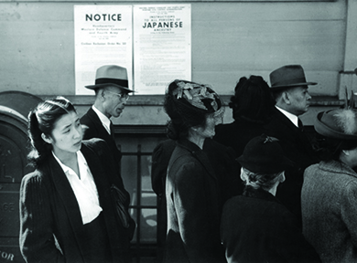
This Photo by Unknown Author is licensed under CC BY
PS-2
I am a temple administrator who manages devotee visits. I’m trying to organize darshan schedules and manage bookings efficiently. But handling visitor details manually is difficult and causes errors. Because there is no simple digital system to manage bookings and schedules. Which makes me feel stressed and reduces management efficiency.
